1. Create a user account with the following attribute
  - username: islam
  - Fullname/comment: Islam Askar
  - Password: islam

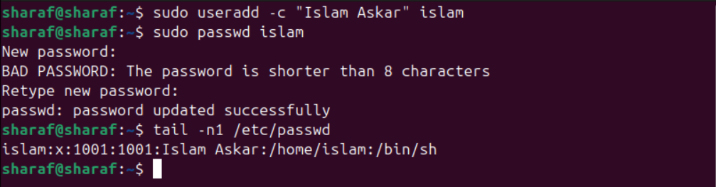
- Create a user account with the following attribute
  - Username: baduser
  - Full name/comment: Bad User
  - Password: baduser

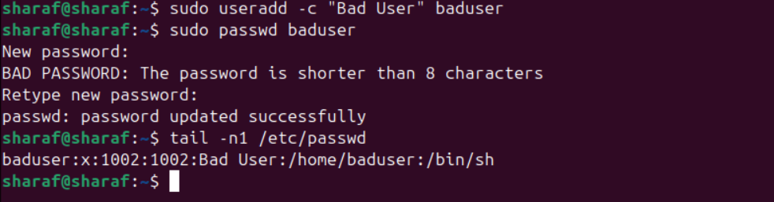
- Create a supplementary (Secondary) group called pgroup with group ID of 30000

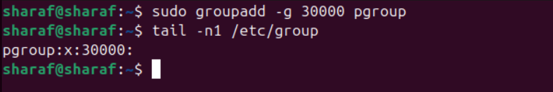

- Create a supplementary group called badgroup

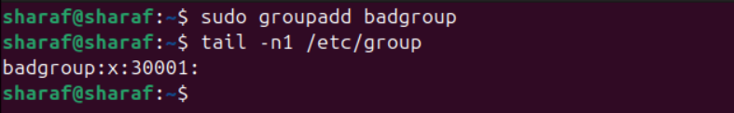
- Add islam user to the pgroup group as a supplementary group

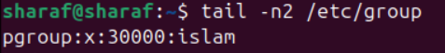
- Modify the password of islam's account to password
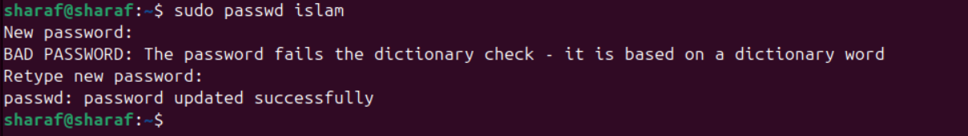
- Modify islam's account so the password expires after 30 days

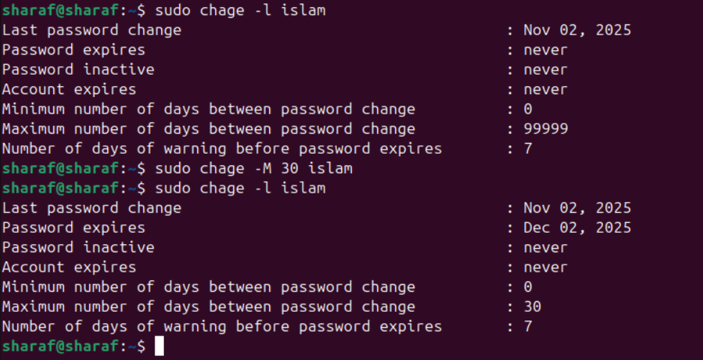

- Lock bad user account so he can't log in
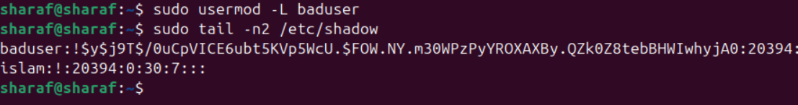
- Delete bad user account
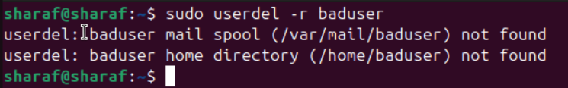
- Delete the supplementary group called badgroup.

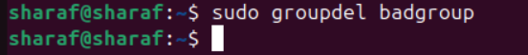

- Create a folder called myteam in your home directory and change its permissions to read only for the owner.

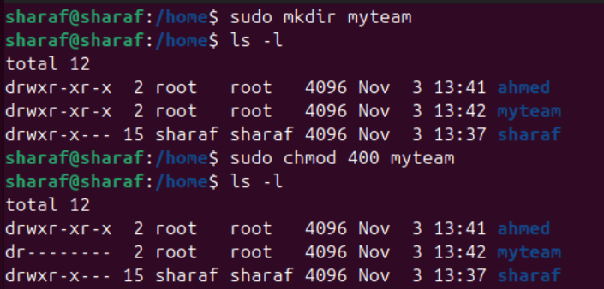

- Log out and log in by another user

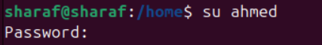

- Try to access (by cd command) the folder (myteam)

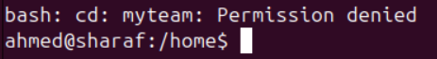

- Using the command Line
  - Change the permissions of oldpasswd file to give owner read and write permissions and for group write and execute and execute only for the others (using chmod in 2 different ways)
- First Way

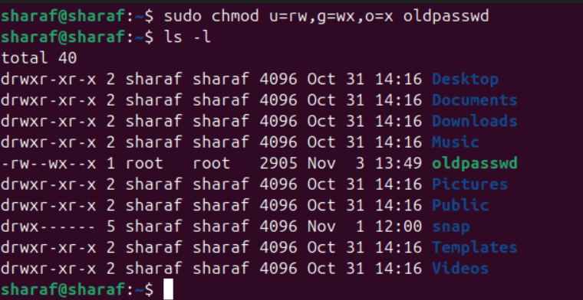

- Second Way
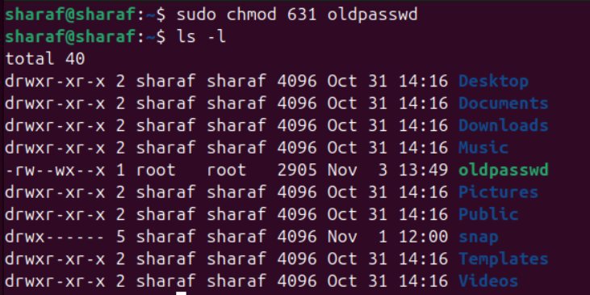

  - Change your default permissions to be as above.

  - what is the maximum permission a file can have, by default when it is just created? And what is that for directory.

Folder | rwx rwx rwx
File | rw-rw-rw-

  - Change your default permissions to be no permission to everyone then create a directory and a file to verify.

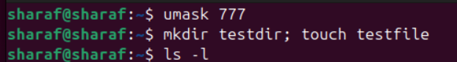

- What are the minimum permission needed for:
Copy a directory:
  - Source
    - r + x
  - Target
    - w + x
Copy a file:
  - Source
    - r
  - Target
    - w + x

Delete a file:
    - No Permission
Change to a directory:
    - X
List a directory content (ls command):
    - X
View a file content (more/cat command):
    - R
Modify a file content:
    - W

- Create a file with permission 444. Try to edit in it and to remove it? Note what happened.

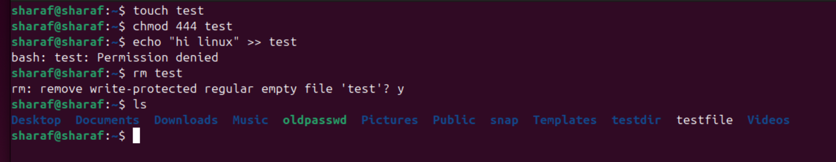

- What is the difference between the “x” permission for a file and for a directory?
File | can be executed (run) as a program
Directory | can enter (access) the directory (cd)

